# Answers to Questions from TT 7.2.1

Name: Nguyen Thi Thanh Minh

Student ID: 104169617

**Hand execution using a trace table**

*Demonstrate how the following code is executed in the computer.*

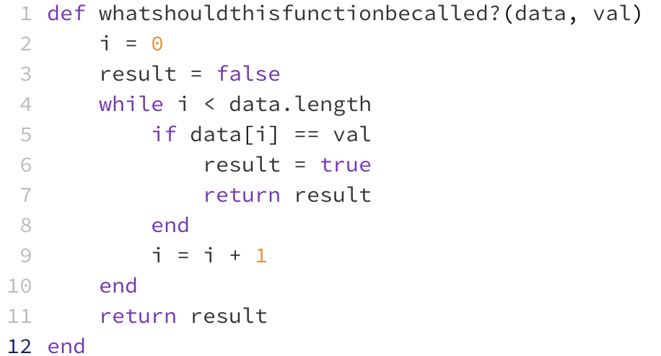

Draw and complete trace tables for the following two sets of data and place the final result in the table below:

false

true

**Once you have completed your trace tables (below) write the name you chose for the function above:**

- I think this function should be named *search_array(data, val)*, because it compares the provided value (passed by *val* argument) with each element of the array (passed by *data* argument)to tell if the value appears in the array. If yes, the *result* (boolean) will be set to “true”, and if not, it will stay “false”.

**Place your trace tables below:**

For data set: **data** = [2, 6, -4, 3, 7] **val** = 3

|  |  |  |  |  |
| --- | --- | --- | --- | --- |
| **data.length** | **val** | **i** | **data[i]** | **result** |
| 5 | 3 | 0 | 2 | false |
|  |  | 1 | 6 | false |
|  |  | 2 | -4 | false |
|  |  | 3 | 3 | true |
|  |  | 4 | 7 | true |
|  |  | 5 | nil | true |

For data set: **data** = [-2, 8, 2, -5, 9] **val** = 6

|  |  |  |  |  |
| --- | --- | --- | --- | --- |
| **data.length** | **val** | **i** | **data[i]** | **result** |
| 5 | 6 | 0 | -2 | false |
|  |  | 1 | 8 | false |
|  |  | 2 | 2 | false |
|  |  | 3 | -5 | false |
|  |  | 4 | 9 | false |
|  |  | 5 | nil | false |